With Crime Cluster 1

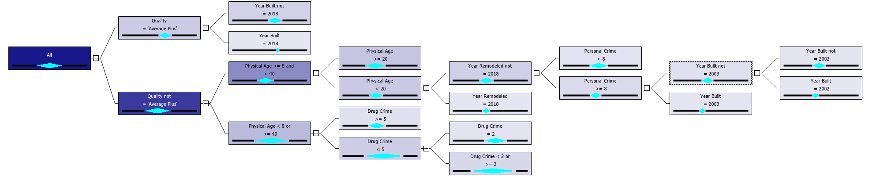

With Crime Cluster 2

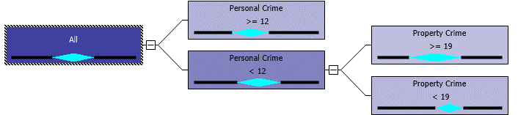

With Crime Cluster 3



Without Crime Cluster 1

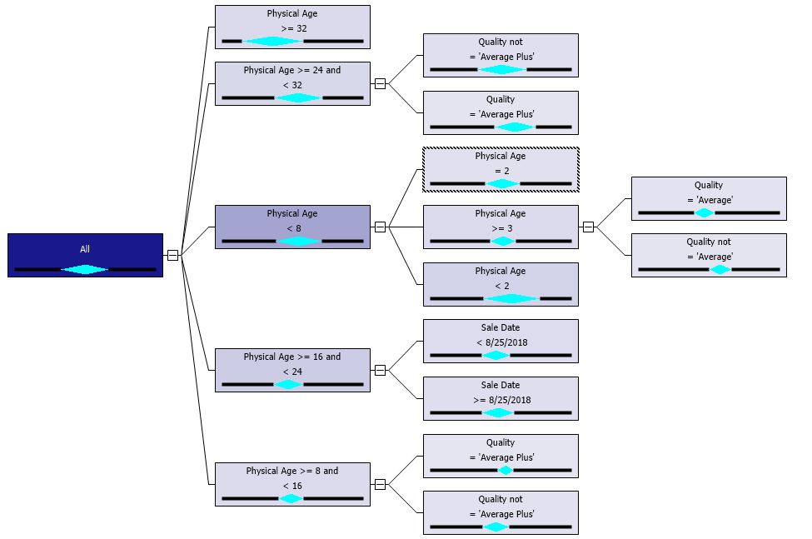

WITHOUT Crime Cluster 2

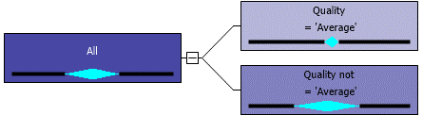

WITHOUT CRIME Cluster 3

